**Karachi:**

Clifton Beach

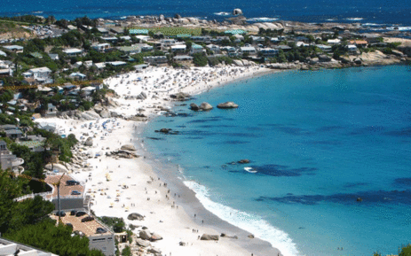

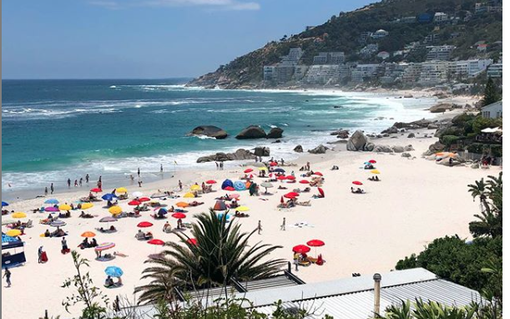

**Clifton Beach** or most commonly known as **Seaview** in Karachi, Sindh, Pakistan located on the Arabian Sea. It stretches from Karachi to Ormara (Balochistan). In 2003 it was affected by an oil spill and polluted with oil. In late 20th century, this beach was rated among most popular and top silver sand beach, but it was affected from oil spill in 2003. A wreckage and cargo of dhow caused the oil spill in the beach and polluted the beach , although the crew members of the wrecked dhow were rescued by Maritime Security Agency. The beach was closed for three days for removal of hay bales and cargo wreckage in the water.